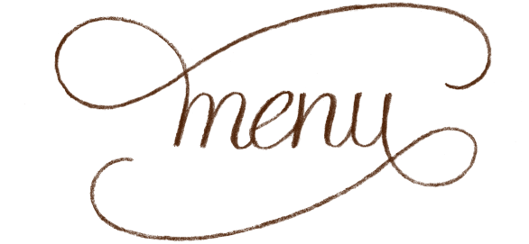

Thanksgiving Day. November 24, 2016 12-6pm | Gormley’s at The Gibson
$50 per person, $15 per child under 10 (children’s menu available)
Non-alcoholic beverage included | Reservations Required

Appetizer
(Choice of one)

Half dozen raw oysters
Shrimp Cocktail
Assorted Fruit, Cheese, Olive Plate with Crackers
Mushroom Pate on Crostini’s
Butternut Squash Bisque

Main Course
(Dinner is served with a side house salad & bread. Substitute a Caesar salad for 3.)

Traditional: Turkey & gravy served with garlic mashed potatoes, green bean casserole, stuffing and cranberry sauce
-Or-
Gormley’s Style: Blackened Grouper filet topped with shrimp etouffe served with rice pilaf and sautéed zucchini & squash medley
-Or-
Gluten-free and vegetarian option available

Dessert
House made pumpkin pie with whipped cream
-Or-
Key lime Pie
